HORMISDALLEN SCHOOL - KYEBANDO

PRE-PLE SET 2 EXAMINATION, 2023

PRIMARY SEVEN MATH

Duration: 2 Hours 15 Minutes

**NAME: ______________________________________________ STREAM: _____________**

EMIS NO.

INDEX NO.

**SECTION A (40 MARKS)**

Questions 1 to 20 carry two marks each

1. Find the sum of 742 and 136

2. Describe the unshaded set region

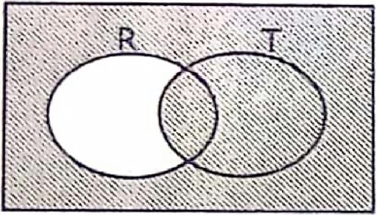

3. Find the LCM of 15 and 18.

4. Baluku had $\frac{4}{9}$ of a cake, if he ate $\frac{1}{2}$ of it, what fraction of the cake did he eat?

5. Find the bearing of M from K.

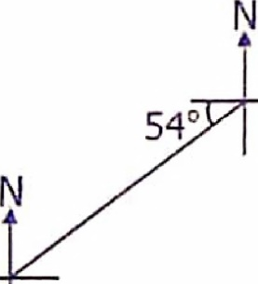

K

M

6. The price of a dress increased by sh.1,875 to sh.16875. By what percentage did the price of the dress increase?

7. Given that 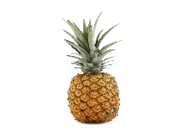 represents 14 pineapples, how many pictures represent 77 pineapples?

8. Express 2:47pm in 24-hour clock system.

9. 3 Litres of petrol cover 70km. How many litres of petrol are needed to cover a distance of 28 km?

10. Simplify: -10 - +10 =

11. Solve for d: 2 – d = 4 (finite 5).

12. The area of a rectangle is 0.39m2. What is the area of the same rectangle in cm2 ?

13. 937 = …………………….hundreds +……………………….tens + ……………..ones

14. Without dividing, show that 1002 is divisible by 6.

15. Using a ruler, a pencil and a pair of compasses only, copy the angle below.

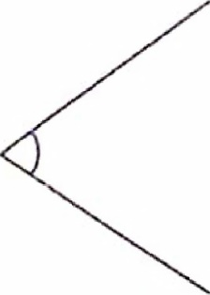

16. Given that set W = {boys}, list all the proper subsets of set W.

17. By tossing a coin once, what is the chance of getting a head appearing on top?

18. Work out: 2 - of 15 + 9

19. Simplify: 0.45 x 5.8

20. An ant moved around the figure below once. Find the distance it covered.

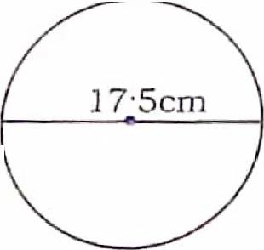

**SECTION B (60 MARKS)**

21. (a) Work out: $\frac{0.08 x 0.28}{0.3 x 0.3}$ (3 marks)

1. Express 0.3636… as a common fraction in its simplest form. (2 marks)

22. (a) Solve and find the solution set for 4 – 2r ≥ -11 + r. (3 marks)

1. Subtract: 4w – 7 from 7w – 2. (2 marks)

23. Below is a table showing exchange rates for various currencies. Use it to answer the questions that follow.

|  |  |  |
| --- | --- | --- |
| **Currency** | **Buying rate (U.sh)** | **Selling rate (U.sh)** |
| 1 US dollar | 3,685 | 3,700 |
| 1 Kenya sh. | 29 | 35 |

1. James travelled to America and returned to Uganda with 1520 US dollars and exchanged it. How much money in Uganda shillings did he get? (2 marks)

(b) If James bought a smart phone worth K.sh.29,600, how many US dollars did he spend on buying a phone? **(3marks)**

24. A cargo truck covered 27 km every hour and moved for 2 hours. Chelimo also covered the same distance running but used 1 hour more than the cargo truck used.

(a) Find the speed in m/s Chelimo used. **(3 marks)**

(b) Find the number of minutes a bus moving at 81 km/hr will take to cover the same distance. **(2 marks)**

25. a) Using a pair of compasses, a ruler and a sharp pencil, construct parallelogram BEAM where BE = 9cm, <BEA = 1350 and EA = 5cm. (4 marks)

b) Measure diagonal AB ………………………………………………. (1 mark)

26. At Mugisha’s wedding party, Asiimwe was assigned a task of seating the visitors on benches at the reception. When he sat them in 8s, 3 visitors remained, when he sat them in 6s, 5 visitors remained but when he sat them in 7s, no visitor remained. Find the least number of visitors they received. **(4 marks)**

27. In a group of farmers, 26 rear birds (B), 2h + 3 rear fish (F) only, h – 1 do rear birds as well as fish.

1. Use the above information to complete the Venn diagram below. **(3 marks)** n(Ɛ)= k

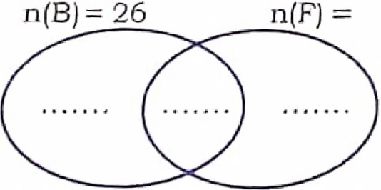

b) Find the value of h given that 37 take only one activity. **(2 marks)**

c) Find the value of k. (1 mark)

28. Okwir borrowed sh.900,000 from Pride microfinance at a simple interest rate of 2.25% per month. If he paid back all the money in $\frac{2}{3}$ years, find the average amount he paid monthly. (5 marks)

29. Below is a rectangular cardboard of length 43 cm and width of 35 cm.

35cm

43cm

1. If Malcom cut circular cards of diameter 7cm, how many circular cards did he cut?

(3 marks)

1. Calculate the area of the cardboard that was wasted. (3 marks)

30. Ekene is 22 years older than his daughter Chioma. In 7 years’ time, Chioma’s age will be a third her father’s age.

1. How old is the father now? **(3 marks)**

(b) Solve: W + 7 – $\frac{2}{5}$ W = 13. **(3 marks)**

31. The exterior and interior angles of regular polygon are in the ratio 1:5 respectively. Calculate the interior angle sum of the polygon.

32. The circle graph below shows the distribution of UPE funds in different votes of a certain quarter of Changweno Primary School. Use it to answer the questions that follow.

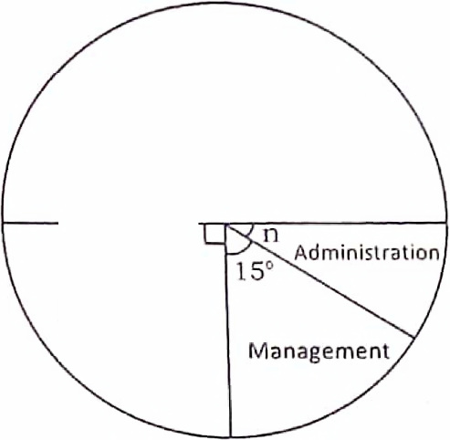

1. Find the value of n. (2 marks)

Co-curricular

1. If administration vote received sh.275,000, how much money did the school receive that quarter. (2 marks)

**END**

**GOOD LUCK**